How to use the Datascape?

The Toflit18 Datascape is a useful tool for exploring the collected data on the French foreign trade during the 18th century. It has several features and the aim of that documentation is to display all the functions and possibilities offered by that device.

The user interface of the home page

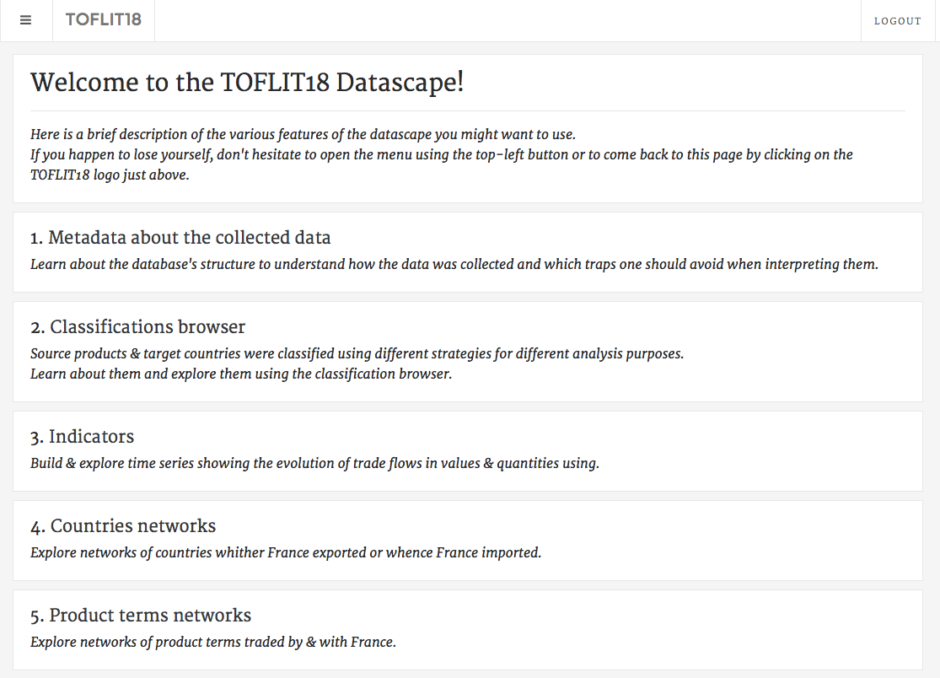

The home page describes the different features of the Datascape you can use. You can come back to the home page at any time by clicking on the toflit18 logo (surrounded in red). All these features will be described below.

1. Metadata about the collected data

By clicking on “Metadata about the collected data”, you can learn some information about the database’s structure and understand how the data was collected. This feature also allows to differentiate uncollected data from collected data.

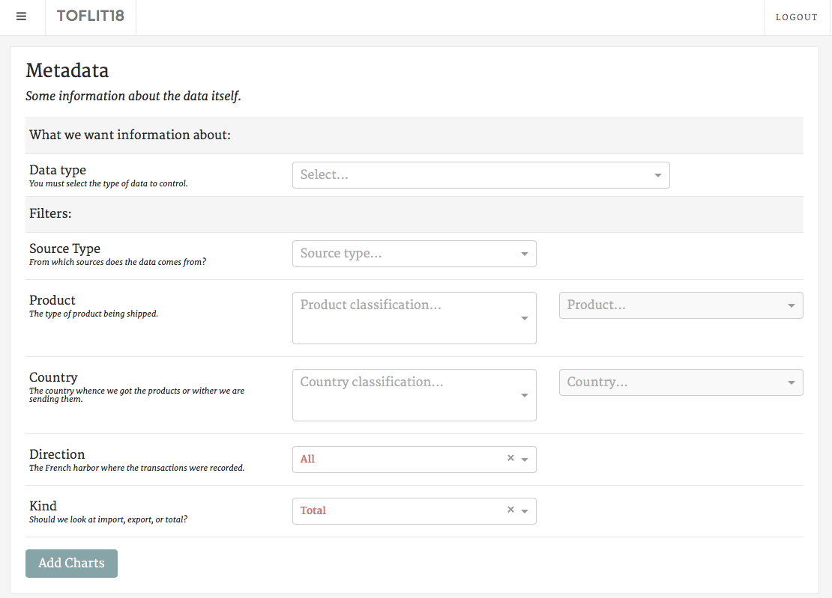

First of all, you need to select the type of data you want information on (“Data type”). There are several types:

* “Direction”: shows all the chambers of commerce from which the data provide, you can see where the data was available and which places in France traded the most.
* “Source type”: shows the types of sources available: national sources, local sources, sources from the former colonies, etc…
* Different merchandises’ classifications:

“Sources”, “Orthographic Normalization” and “Simplification” concern the spelling of merchandises (how it is written in the sources, how they were normalized and simplified);

“Medicinal products”, “Hamburg classification”, “North America”, “Eden Treaty”, “Grains”, “SITC”, “SITC EN” and “SITC FR” are several other merchandises’ classifications.  
These types of data show the occurrences (number of flows) of each category of the classification selected for every year.

* Different geographic classifications:

“Sources”, “Orthographic Normalization” and “Simplification” concern the spelling of countries (how it is written in the sources, how they were normalized and simplified);

“Grouping” and “O’Brien” are countries’ classifications.

These types of data show the number of flow of each country or category of the classification selected for every year.

Thus, you can use filters to choose a source type, a category of products (or just a single product), a group of countries (or just a single country), a direction and you can separate exports from imports.

After your choices were made, you may click on the “Add Charts” button to obtain the relevant information.

1. Classifications browser

By clicking on “Classifications browser”, you can find all the classifications for products and countries and all the items included in each category of classification.

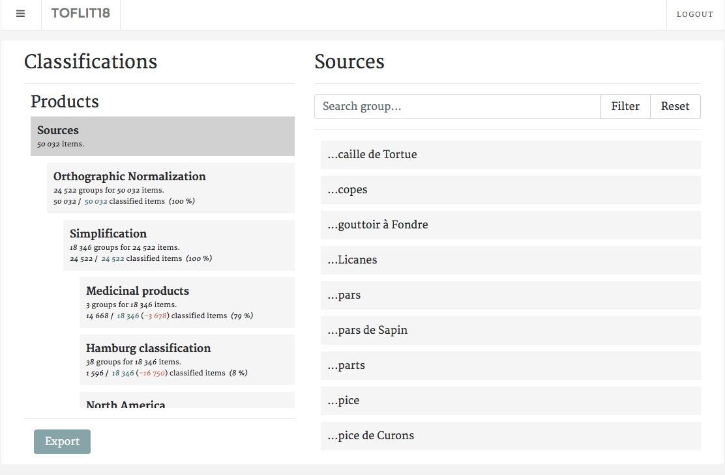

For example, if you want to find out how an item was classified in the SITC (Standard International Trade Classification), click on SITC inside the scroll-down menu on the left and write the name of the item on the area “Search item”. Then, press Enter or click on Filter for the datascape to show you the classification.

E.G.: “Tabac en feuilles” is classified into the category n°1 in the SITC classification.

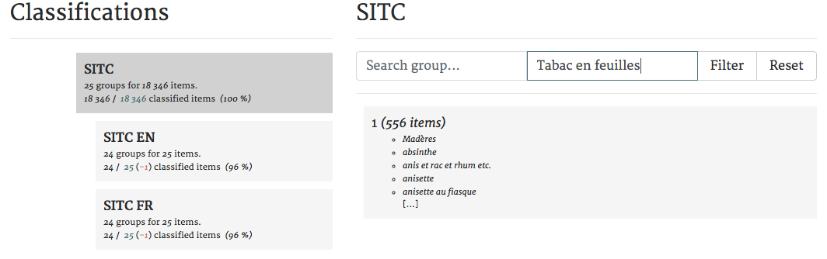

You may select SITC EN to see the details concerning the categories, there significations, and, for example, understand what category n°1 stands for.

You can also do the same thing with countries’ classification. Sometimes, in the sources, the place indicated is not a country but a city or a region. For example, “Venise” is classified inside “Italie” in the classification Grouping.

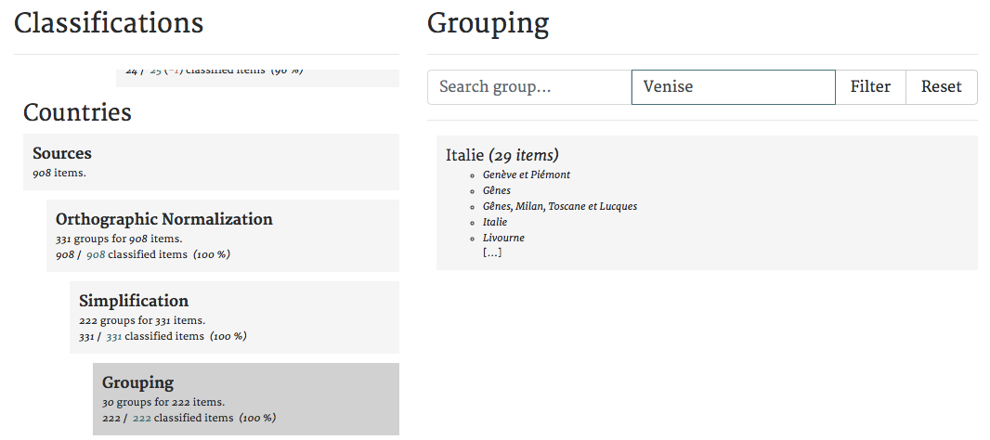

1. Indicators

By clicking on “Indicators”, you can explore the database and discover time series showing the evolution of trade flows. You can see the number of flows and its value per year, choosing one direction or all, and the number of elements per year by direction.

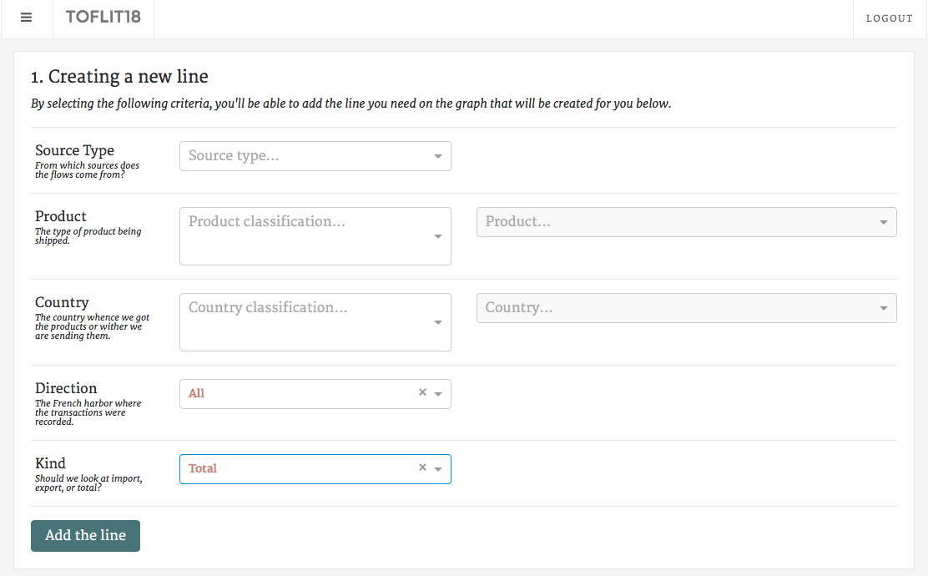

As in the category “Metadata about the collected data”, you can choose which source type you want to keep and which product you would like information on. You can also choose a country with which France has traded, a direction and a kind (Exports or Imports). Then you may click on “Add the line” and explore the results.

Of course, you can fill in none of the criteria, click on “Add the line” and have results about the entire database. As shown in the following example: you can see the number of flows per year and its value from all the sources, and the number of directions per year found in the database.

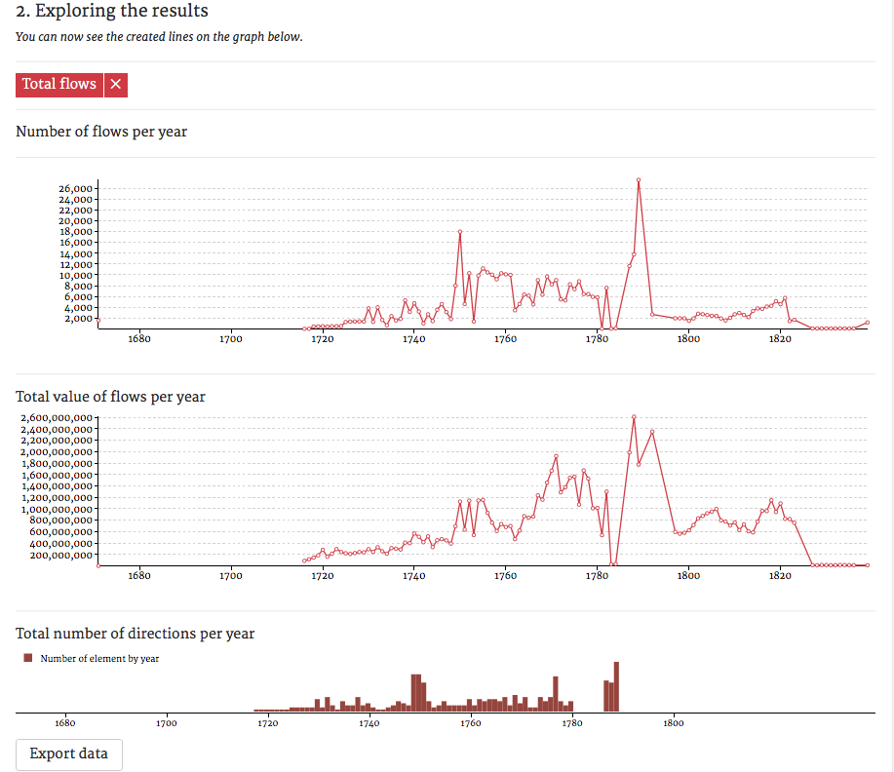

Additionally, you can compare several time series. For instance, you can compare the evolution of imports and exports, you just have to select Imports in the criteria « Kind » and « Add the line »; then you may do the same thing with Exports and both graphs will come on top of each other.

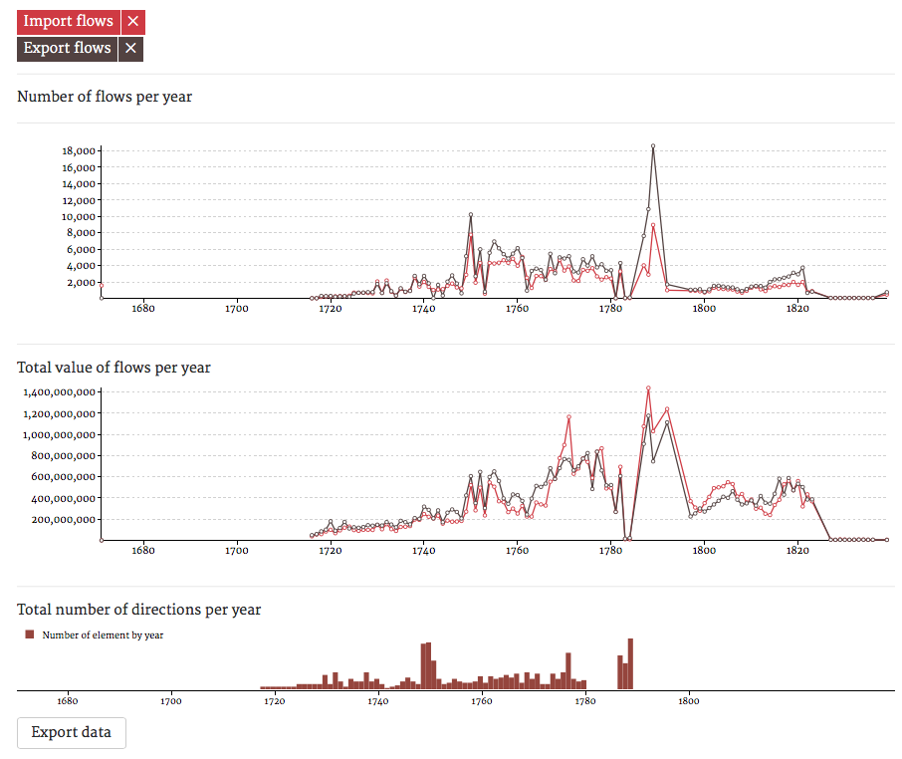

To export the data in text-form, use the “Export data” button on the bottom right of the page.

1. Countries network

By clicking on “Countries network”, you can explore relationship between directions and countries, between places of trade in France and their partners.

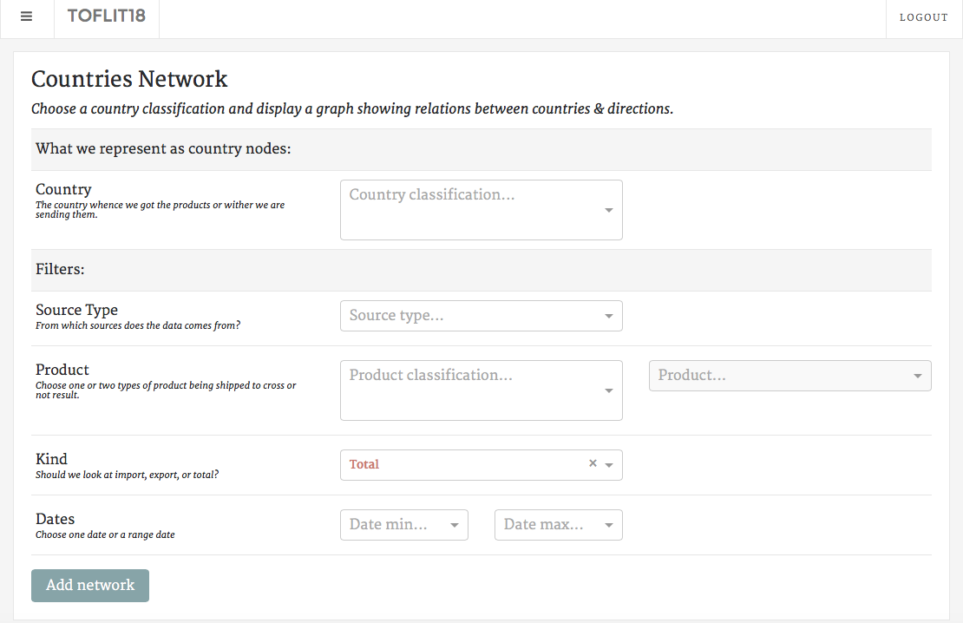

First, you shall select which country classification you wish to work on. Then you might choose filters (even though it is not required to add a network): source type, product, kind (Imports or Exports) and dates.

Thereafter, click on “Add network”, and the graph representing the network you selected will appear. For example, we have chosen “simplification” as country nodes without any filter.

That is what appears on the screen:

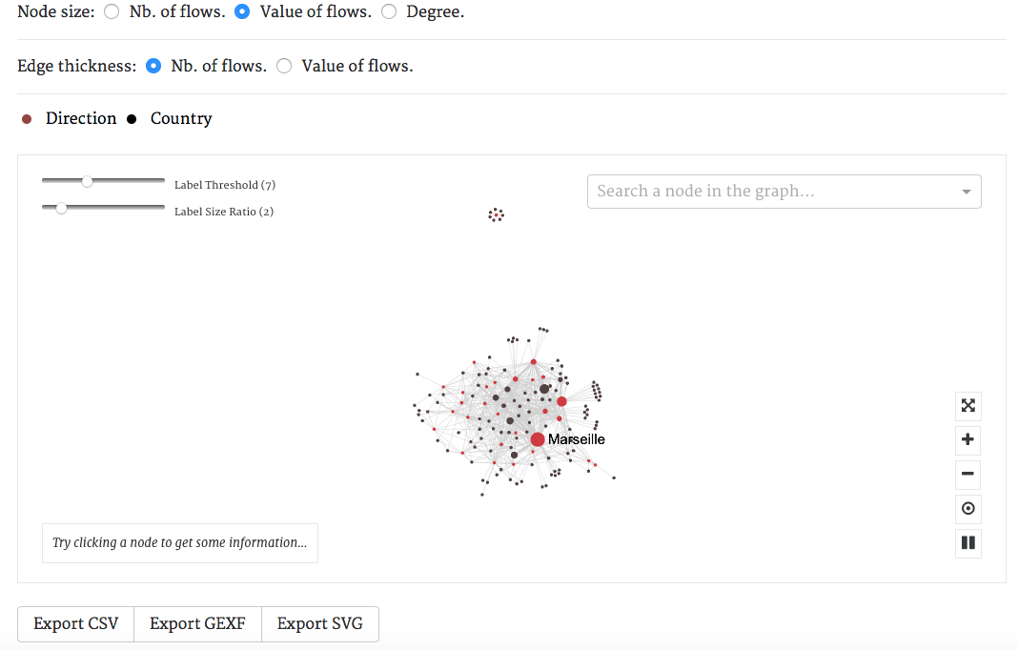

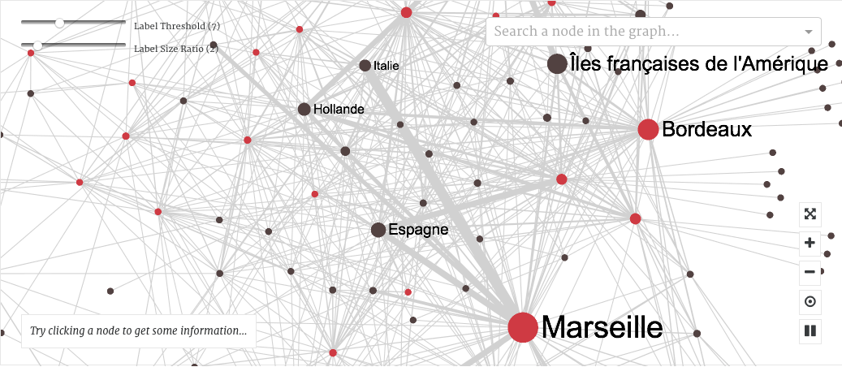

You can see a real network and you can “play” with it. Zoom in if you’d like a better visibility of relationships between directions and countries.

In that interface, you have different possibilities with different buttons:



Put the network representation in full screen

Zoom in or zoom out

Restart the initial representation

Break the representation

Moreover, you can choose if you want the nodes to represent the number of flows between directions and countries, or the value of flows. Thus, the bigger the node is, the higher the number or the value of flows.

You can do the same thing with the links between nodes (choose between number or value of flows).

Furthermore, you can also see more labels of countries and directions by diminishing the label threshold and increase the size of these labels by raising the label size ratio.

Finally, you can search a node in the representation with the tool “Search a node in the graph” and get some information on the country or direction chosen by clicking on a node (you will obtain the number of flows, the value of these flows and the degree).

In order to export your results, you may choose between the following file formats : CSV, GEFX or SVG.

1. Product terms network

By clicking on “Product terms network”, you can explore relationships between product terms traded by and with France. It allows you to see how products terms can be related (as an example, the products “feuilles de tabac” and “feuilles de fer” are linked by the term “feuilles”).

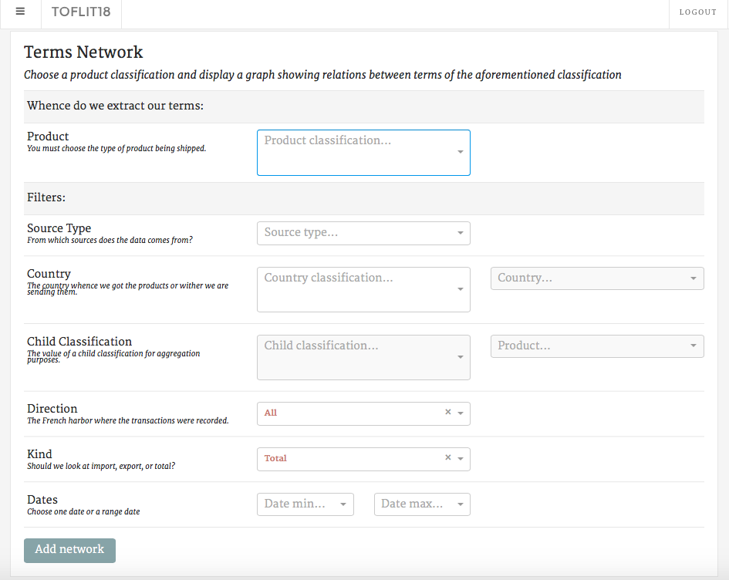

First, you must select which product classification you wish to work on. Then you might choose filters (even though it is not required to add a network): source type, country, direction, kind (Imports or Exports) and dates.

Thereafter, click on “Add network”, and the graph representing the network you selected will appear. For example, we have chosen “simplification” as products nodes without adding any filter.

That is what appears on the screen:

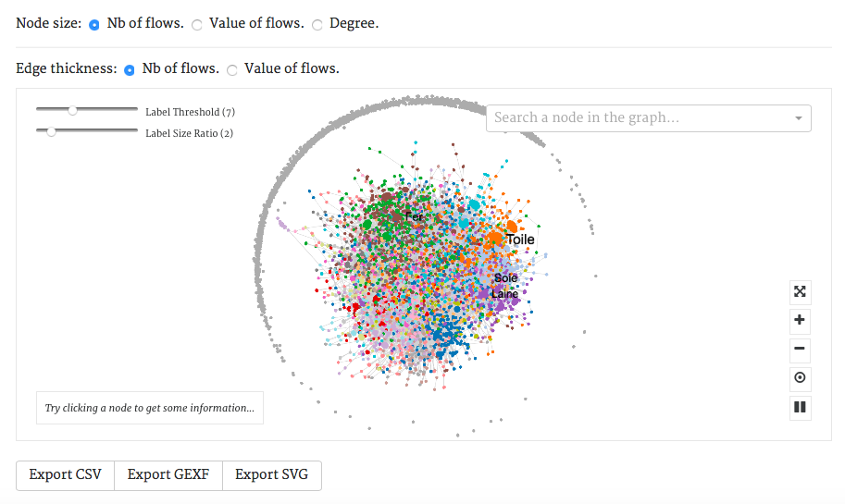

You can apply the same options that are detailed in “Countries network” except it concerns products, not countries and directions.

By clicking on a node, you will be able to see the number of flows of that product term, its total value and the degree of that term.